PROJECT DOCUMENTATION

# PROJECT TITLE:

INVENTORY MANAGEMENT SYSTEM (FRONTEND)

# PROJECT ID:

NM2025TMID39351

# TEAM LEADER:

NAME: Prem Kumar. R  
MAIL ID: prempremkumar68605@gmail.com

# TEAM MEMBERS:

|  |  |
| --- | --- |
| Member Name | Email ID |
| Vignesh. P | vickyvicky60077@gmail.com |
| Gopinath. S | rsenthilgopinath@gmail.com |
| Mohamed Riyaz. S | riyazabbas59@gmail.com |

# 1. PURPOSE:

To simplify inventory management by providing a clean and responsive interface that allows users to view, add, and track products, monitor sales, and manage their cart — improving business efficiency and saving time.

# 2. PROJECT OBJECTIVE:

- User-Friendly Interface: Help businesses quickly manage inventory and sales with an intuitive UI.  
- Efficiency: Minimize manual effort and errors by centralizing inventory tracking.  
- Scalability: Designed to be extendable with a backend for real-world deployment.

# 3. ARCHITECTURE:

FRONTEND:  
 - React.js (component-based UI)  
 - Tailwind CSS (for responsive styling)  
  
BACKEND:  
 - None in this project (Frontend-only), but can be connected to Node.js / Express / Database in future.

# 4. SETUP INSTRUCTIONS:

PRE-REQUISITES:  
- Node.js and npm  
- React.js  
- Git (optional)  
- Code editor (VS Code or Acode on mobile)  
  
INSTALLATION STEPS:  
1. Clone or extract the project folder.  
2. Open terminal and navigate to project directory:  
 cd inventory-management-frontend  
3. Install dependencies:  
 npm install  
4. Start the development server:  
 npm start  
5. Open browser and go to:  
 http://localhost:3000

# 5. PROJECT STRUCTURE:

inventory-management-frontend/  
├── public/ # Static files (index.html, icons, images)  
├── src/ # React source code  
│ ├── components/ # UI components (NavBar, ProductList, Cart, Sales)  
│ ├── context/ # Context API for state management  
│ ├── pages/ # Pages like NotFound  
│ ├── App.js # Root component  
│ └── index.js # Entry point  
├── tailwind.config.js # Tailwind CSS configuration  
├── package.json # Dependencies and scripts  
└── README.md # Documentation

# 6. RUNNING THE APPLICATION:

FRONTEND:  
 npm install  
 npm start  
  
Access the application in browser at http://localhost:3000

# 7. AUTHENTICATION:

Not implemented in this project (Frontend only).  
Can be integrated in the future using JWT or OAuth for secure login.

# 8. API DOCUMENTATION:

Not applicable – this project currently does not use backend APIs. Future integration possible for:  
- /api/products – Fetch inventory from database  
- /api/sales – Record and retrieve sales data

# 9. USER INTERFACE:

This project features:  
- Product Catalog page for browsing available items.  
- Add Product form for adding new inventory items.  
- Cart page for viewing selected products.  
- Sales page to display purchase history.  
- A responsive navigation bar for smooth navigation.

# 10. TESTING:

- Manual Testing: Checked on desktop and mobile browsers  
- Tools Used: Chrome DevTools, React Developer Tools

# 11. KNOWN ISSUES:

- Data is stored in local memory (not persistent)  
- Requires manual backend integration for production use

# 12. FUTURE ENHANCEMENTS:

- Backend integration with database (MongoDB or Firebase)  
- Authentication (Login / Signup)  
- Data analytics dashboard  
- Export inventory/sales as CSV or PDF

13.SCREENSHOTS

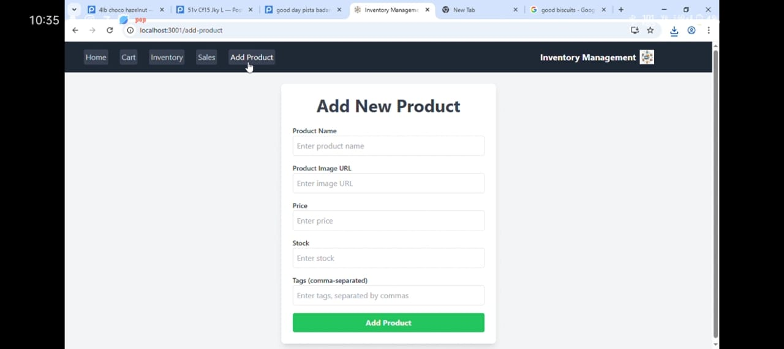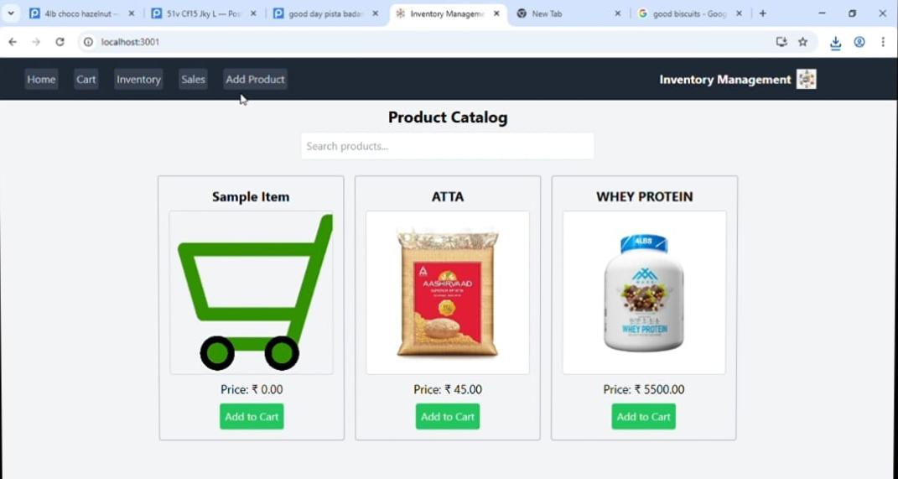**ADD THE PRODUCTS YOU ARE GOING TO BUY**